**EX NO: 13 Simulate elliptical orbits in Pygame**

**Date :**

**AIM**

To simulate elliptical orbits in pygame.

**ALGORITHM**

**Step 1:**  Import and initialize pygame with **pygame.init()  
Step 2:** Create a graphical screen (Surface) with pygame.display.set_mode().  
**Step 3:** Draw earth, moon and elliptical orbit  
**Step 4:** Inside the infinite loop, change the center of the moon x1, y1 as follows:

x1 = int(math.cos( degree * 2 * math.pi / 360) * xRadius) + 300  
 y1 = int(math.sin(degree * 2 * math.pi / 360) * yRadius) + 150

**Step 5:** Redraw earth, moon and elliptical orbit  
**Step 6:** The pygame.display.flip() method makes everything we have drawn on the screen Surface become visible.  
**Step 7:** If user triggers quit() event (close button), the simulation stops.

**SOURCE CODE**

import pygame

import math

import sys

pygame.init()

screen = pygame.display.set_mode( (600, 300))

clock = pygame.time.Clock()

while(True) :

for event in pygame.event.get() :

if event.type == pygame.QUIT:

sys.exit()

xRadius = 250

yRadius = 100

for degree in range(0,360,10) :

x1 = int(math.cos( degree * 2 * math.pi / 360) * xRadius) + 300

y1 = int(math.sin(degree * 2 * math.pi / 360) * yRadius) + 150

screen.fill(( 0, 0, 0))

pygame.draw.circle(screen, (255, 0, 0), [300, 150], 35)

pygame.draw.ellipse(screen, (255, 255, 255), [50, 50, 500, 200], 1)

pygame.draw.circle(screen, (0, 0, 255), [x1, y1], 15)

pygame.display.flip()

clock.tick(5)

**OUTPUT**

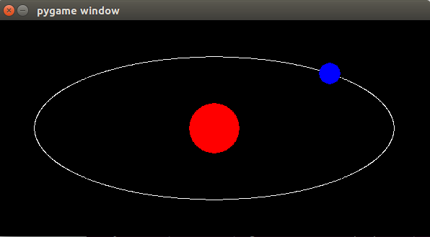

**RESULT**

Thus the elliptical orbits in pygame was simulated successfully.